Project Design Phase-II Data Flow Diagram

|  |  |
| --- | --- |
| Date | 15 October 2022 |
| Team ID | PNT2022TMID18477 |
| Project Name | Project - Inventory Management System for Retailers |
| Maximum Marks | 4 Marks |

**Data Flow Diagram**

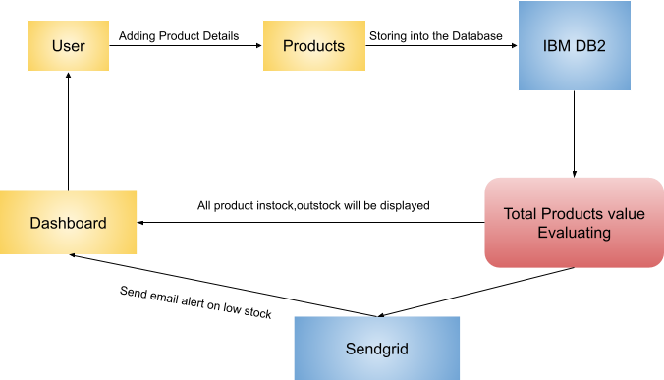

**User Stories**

|  |  |  |  |  |  |  |
| --- | --- | --- | --- | --- | --- | --- |
| **User Type** | **Functional**  **Requirement (Epic)** | **User Story Number** | **User Story / Task** | **Acceptance criteria** | **Priority** | **Release** |
| Retailer(Web user) | Registration | USN-1 | As a user, I can register for the application by  entering my email, password, and confirming my password. | I will be redirected to login page | High | Sprint-1 |
|  | USN-2 | As a user, I will receive confirmation email once I have registered for the application | I can receive confirmation email & click confirm | High | Sprint-1 |
|  | USN-3 | As a user, I can register for the application through Facebook | I can register & access the dashboard with Facebook Login | Low | Sprint-2 |
|  | USN-4 | As a user, I can register for the application through Gmail | I can verify the OTP number | Medium | Sprint-1 |
|  | Login | USN-5 | As a user, I can log into the application by entering email & password | I can access my account / dashboard | High | Sprint-1 |
|  | Dashboard | USN-6 | As a user,I can update stock in & out count details | Updation can be made through barcode scanning | High | Sprint -2 |
|  | Dashboard | USN-7 | As a user,I can check the low stock details through alert message | Alert message can be received by registered mail | High | Sprint -1 |
|  |  | USN-8 | As a user,I can check the total product details | I can view the value of total products in the stock | Medium | Sprint -2 |
|  |  | USN-9 | As a user,I can check the high demand product details | I can update sales details of the products | High | Sprint -2 |
|  |  | USN-10 | As a user,I can generate the invoice details | I can add incoming stock details | High | Sprint -1 |